DIRECT SERVICE PROFESSIONAL (DSP) TRAINING STIPEND PROGRAM

DSP Training Stipend Program:
DSPs can receive up to two (2) $625 stipends (before taxes) when they complete approved training courses through June 30, 2024. Vendors are eligible to receive $150 for employer related costs.

Purpose:
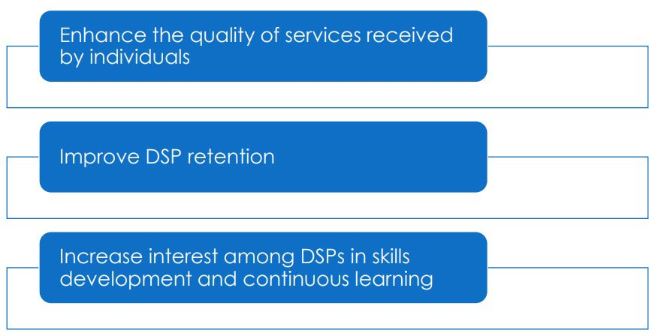

DSP Stipend Eligibility
To be eligible for the training stipend, DSPs, including some frontline supervisors and clinical staff, must meet the following eligibility requirements:
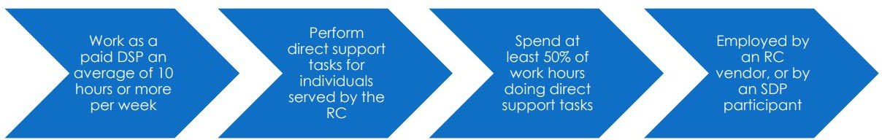

The following are NOT eligible even if a portion of their work involves providing direct support:
- Staff paid through a funding source other than the regional center, such as Medi-Cal, IHSS, health insurance, or a school district. The only exceptions are: ICF-DD, ICF-DDN, ICF-DDH.
- Those who only provide intermittent service such as home modification and/or meal delivery services;
- Staff employed through a temporary personnel agency;
- Contract or 1099 workers;
- On-call or ‘As Needed’ workers;
- Natural supports;
- Volunteers; and
- Administrative or supervisory staff, unless they spend 50% or more of their time doing direct support work.

GGRC DSP Training Stipend Program Process
- Vendors will need to submit and sign the Training Stipend Agreement form; link for signature via DocuSign below. A fully executed copy will be returned to the vendor via Docusign.
Link to sign agreement: DSP Training Stipend Agreement

- GGRC will enter T$ sub-code with a rate of $775 in the rate table for the DSP stipend(s). This rate includes the $625 payment for the DSP, plus the $150 payment for the Employer Related Costs.

- DSP to create ARCA Learn account: https://www.arcalearn.org/Login/Login.aspx

- DSP to obtain the appropriate GGRC (6 digit) vendor number from their employer prior to logging in to complete their approved training course. (This will be required to obtain stipend reimbursement).

- DSP to complete approved training course, and brief survey. Please note, all training must be completed no later than June 30, 2024, to be eligible for the DSP stipend.
- DSP to receive a Certificate of Completion via email.
- GGRC will access weekly activity reports via ARCA Learn every Monday. A copy of this report will be sent to the vendor via email and Vendor will be required to review and confirm the employees listed on the activity report and confirm the number of trainings taken per employee. A maximum of two (2) stipends will be paid per employee.

- After receiving confirmation from Vendor, GGRC will issue a ‘Contract’ authorization for the one (1) designated sub-code for billing.
- Vendors will be required to bill the total number of trainings in Ebilling and submit no later than the 2nd business day of the month.

- GGRC will issue payment for approved stipends on or about the 13th of the month.

- GGRC Vendor (DSP Employer) is obligated to issue stipend payments to DSP within 90 days after training completion.

- For questions, DSP and/or vendors may reach out to workforce@ggrc.org

Billing Process:

The regional center email address that vendors can use to submit payment inquiries is: workforce@ggrc.org

More information can be found at: https://www.dds.ca.gov/initiatives/workforce-initiatives

Approved DSP training courses are available in the ARCA Learning Center at: https://provider.arcalearn.org

To register, the DSP must input their employer’s vendor number, verify the vendor’s name, and input the name of the regional center associated with the vendor number.

